**Salesforce Implementation Project**

**Title:** Smart City Waste & Recycling Management System  
**Domain:** Smart Cities / Municipal Services **Solution Category:** Salesforce CRM + IoT Integration

**Primary Users:** City Officials, Waste Collection Staff, Truck Drivers, and Citizens.

**Problem Statement**

➤ GreenCity Municipal Corporation faces growing challenges in managing urban waste and recycling. Overflowing bins, inefficient truck routing, and limited citizen participation create operational inefficiencies, higher costs, and environmental concerns.

➤ To address this, the corporation requires a **Salesforce-based Waste & Recycling Management Platform** that:

**•** Tracks waste bins, IoT fill-level data, trucks, and routes.

**•** Automates waste pickup assignment to nearest available trucks.

**•** Provides real-time notifications to citizens.

**•** Rewards citizens for recycling participation.

**•** Enables predictive dashboards for sustainable decision-making.

**Phase - 1 : Problem Understanding & Industry Analysis**

**Requirements Analysis**

**➣System Needs**

• Maintain detailed records of bins, including geographic location and IoT-based fill level data.

**•** Track fleet information: drivers, vehicle capacity, and assigned collection zones.

**•** Ensure pickup requests are generated automatically and avoid duplication for the same bin.

**•** Provide real-time communication to citizens regarding bin collection and reward point updates.

**•** Deliver analytical dashboards to city officials for performance and sustainability insights.

**➣Key Stakeholders & Their Expectations**

**• Municipal Administrators** → Require visibility into waste collection patterns, recycling rates, and cost savings through dashboards.

**• Truck Operators** → Need efficient job allocation that considers proximity and load capacity.

**• Community Members** → Expect timely waste collection services and transparency in reward programs.

**• Technical Support Team** → Responsible for IoT connectivity, data synchronization, and smooth functioning of recycling records.

**➣Current vs. Proposed Workflow**

1. **Existing Approach:** Collection relies heavily on manual reporting, complaint calls, and irregular routing. This leads to inefficiencies, delays, and dissatisfaction among residents.

**ii) Planned Salesforce-Enabled Workflow:**

**•** IoT sensors detect when bins reach capacity.

**•** A pickup request is generated and automatically assigned to the closest available truck.

**•** Citizens are notified of the collection status and updated reward balances.

**•** Dashboards consolidate data for city officials, providing clear operational insights.

**➣Industry Context & Special Considerations**

**•** Smart city initiatives emphasize sustainability and efficiency in public services.

**•** Recycling adoption improves significantly when linked to gamified reward systems.

**•** IoT technology supports predictive analysis for route optimization and overflow prevention.

**➣Technology & Marketplace Exploration**

**• Mapping and Route Tools →** GIS integration to streamline driver assignments.

**• IoT Middleware Solutions →** Connect bin-level sensors directly with Salesforce records.

**• Gamification / Rewards Apps →** Enhance citizen engagement through redeemable points.

**Phase 2: Org Setup & Configuration**

**➣Salesforce Editions**

For this project, a Salesforce Developer Edition Org was selected. It is free, comes with all core CRM capabilities, and supports both configuration (Admin) and coding (Apex, LWC). This edition is ideal for building, testing, and demonstrating the Smart City Waste & Recycling solution.

**➣Company Profile Setup**

The company profile was set up with the name GreenCity Waste & Recycling, using the Asia/Kolkata (GMT +5:30) time zone, English (India) locale, and English as the default language. The currency was configured as INR (Indian Rupee) to match local financial standards. These settings ensure the org reflects regional operations and reporting needs.

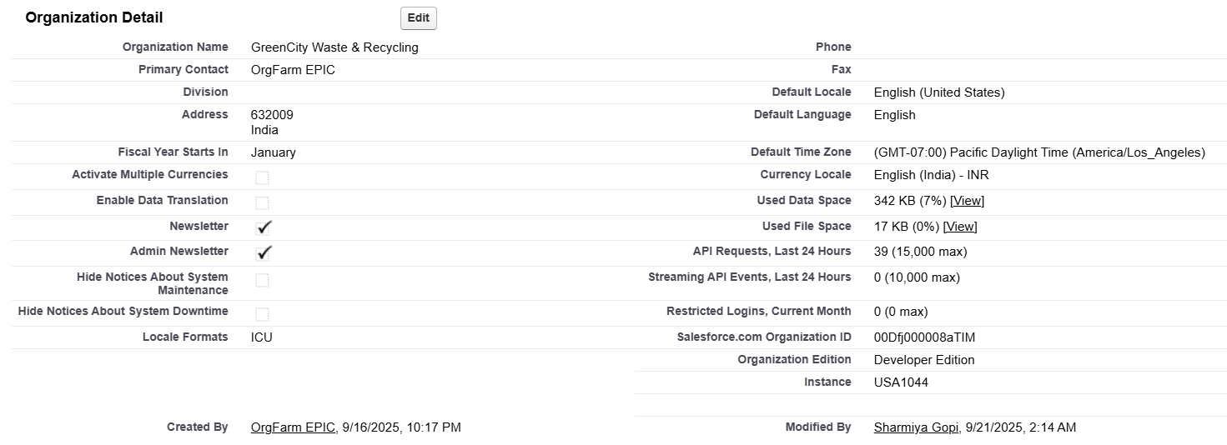

**➣Business Hours & Holidays**

**• Business Hours:** “Waste Collection Hours” → 6:00 AM to 10:00 PM, Monday–Sunday

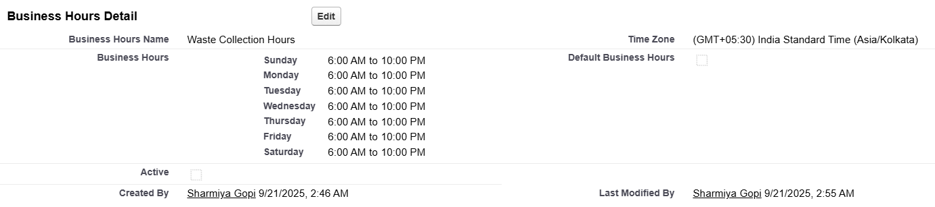

**• Holidays Configured:** Diwali, Republic Day, Independence Day

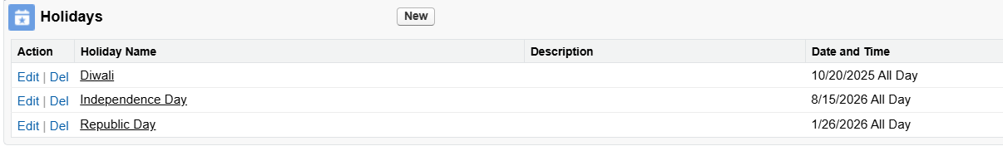

**➣Fiscal Year Settings**

The fiscal year is kept as Standard (Jan–Dec). This supports financial reporting aligned with city budget cycles and allows sustainability dashboards to reset annually.

**➣User Setup & Licenses**

Created representative users for key roles:

• Commissioner (System Administrator License)

• Operations Manager (Salesforce Platform License)

• Route Supervisor (Salesforce Platform License)

These simulate the different personas that interact with the system.

**➣Profiles**

Custom profiles were cloned from Standard User and modified:

**• Operations_Manager_Profile** → Full access to bins, trucks, and pickups.

**• Route_Supervisor_Profile** → Moderate access; cannot delete.

**• Truck_Driver_Profile** → Limited to viewing bins and updating assigned pickups.

**➣Roles**

A role hierarchy was created to reflect municipal reporting.

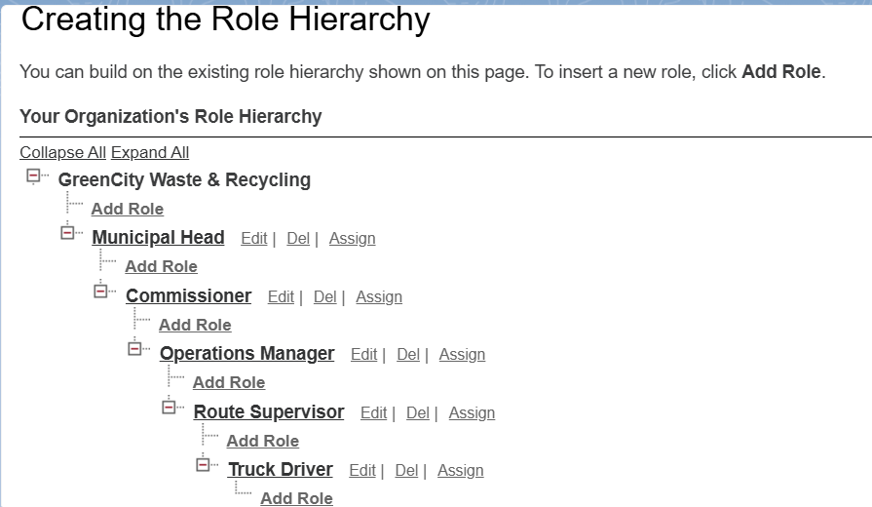

**➣Permission Sets**

**Reward_Manager:** Grants edit rights on citizen reward points.

Permission sets were used instead of modifying profiles directly to keep security flexible.

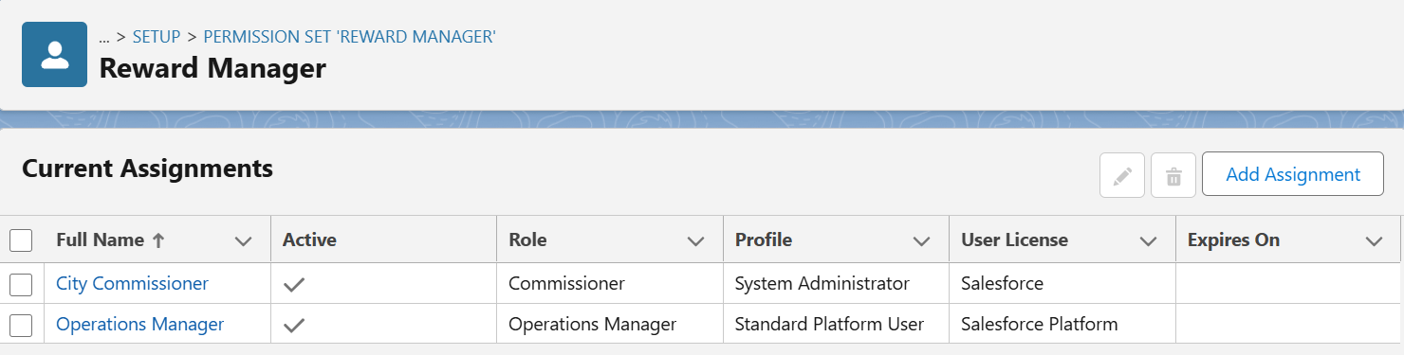

**➣OWD (Org-Wide Defaults)**

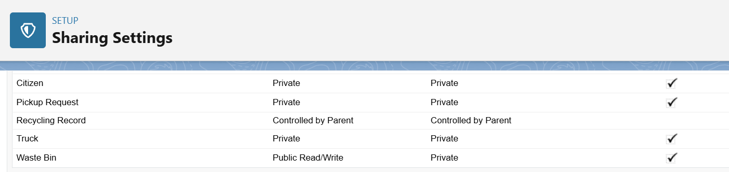

This enforces least-privilege access while allowing collaboration on bins.

**➣Sharing Rules**

**• Criteria-Based Rule:** Pickup Requests with Zone = “North” are shared with the North Route Supervisor role.

**• Owner-Based Rule:** Pickup Requests owned by the Pickup Requests Queue are shared with Route Supervisors

**➣Login Access Policies**

**•** “Administrators can log in as any user” enabled (for testing).

**•** Session timeout set to 30 minutes.

**•** MFA enabled for all admin and manager-level accounts.

**➣Dev Org Setup**

A Developer Edition Org was initialized with company info, roles, users, and OWD as described. This environment serves as the baseline for building custom objects, flows, triggers, and integrations.

**_____________________________________________________________________**